1. Where to place JavaScript code in the HTML file?

JavaScript code will be executed immediately while the page loads into the browser. This is not always what we want the JavaScript code to run. Sometimes we want to execute a script when a page loads other times when the user triggers an event. There are various ways to include JS code in our HTML file.

* Scripts in <head>…</head> section of HTML
* Scripts in <body>…</body> section of HTML
* Scripts in <head>…</head> and <body>…</body> sections of HTML
* Scripts in an external file and then include in <head>…</head> section of HTML

1. Scripts in <head>…</head> section of HTML:

If we want the JavaScript code should be executed when it is called or when an event is triggered then we should keep it in the head section.

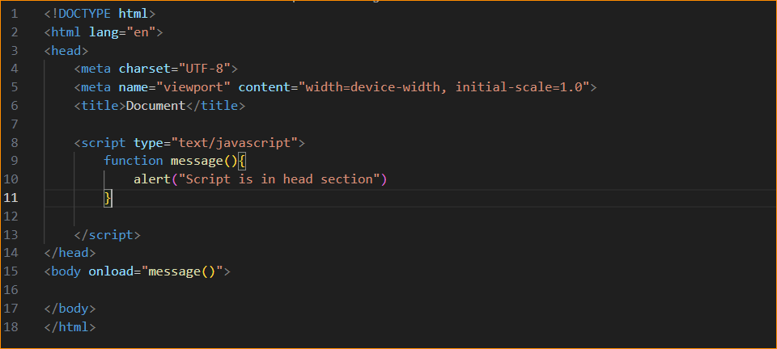

1. Scripts in <body>…</body> section of HTML

If we want the script should be run when the page loads then we should keep the JavaScript program in the body section. If we place a script in the body section it will generate the content on the page.

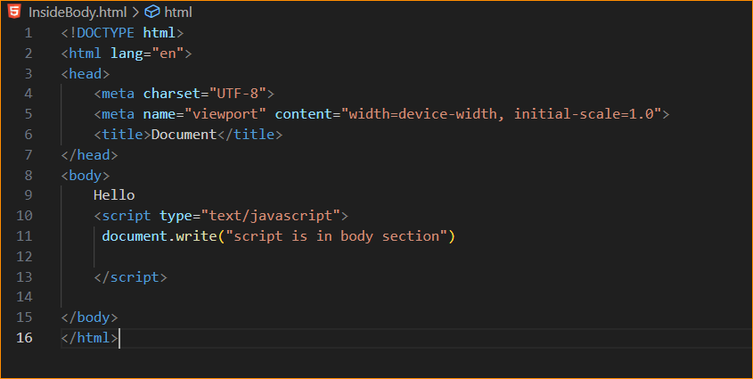

Result –



1. Scripts in <head>…</head> and <body>…</body> sections of HTML

We can place an unlimited number of scripts in the HTML file in the head or body section. So we can have the script in both the body and the head section also.

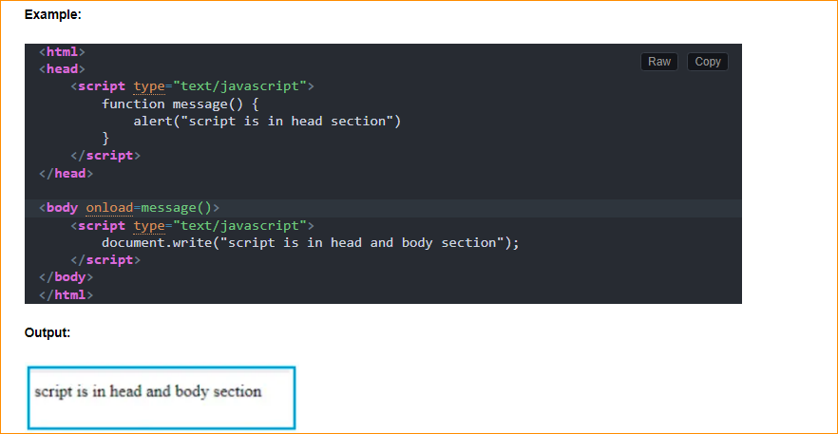

Scripts in an external file and then include in <head>…</head> section of HTML:

If we want to reuse a single script code on multiple pages then we can place the script in an external file. The script tag provides a method to store JavaScript in an external file and then include it into HTML files using the src attribute of the script tag. An external JavaScript file generally has a .js extension. It is good practice to places all JavaScript files into a single JS file.

The advantage of using an external JS file is that editing the script file has become easier as it can be done in one location, rather than editing the code in the script tags on each page containing the script.

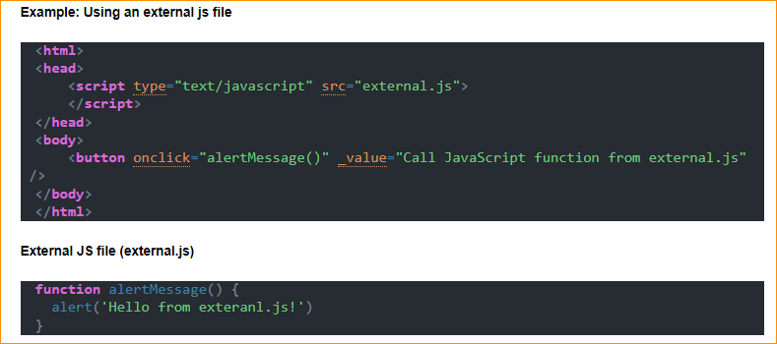

1. Advantages of external JavaScript over inline JavaScript:

You will get the following advantages of using external JavaScript files over the inline JavaScript

**Maintainability and Reusability:** You can refer to the external JavaScript files on multiple pages without having to duplicate the code on every page. That means you can reuse the same JavaScript code on multiple pages. If you need to change something, then you need to change only in one place. As a result, maintenance will become easier.

**Separation of Concerns:** As we are storing the JavaScript file in a separate .js file, so it adheres to the separation of concerns design principle. In general, it is always a good practice to separate HTML, CSS, and JavaScript as it makes it easier to work with them. As well as it also allows multiple developers to work simultaneously.

**Performance:** The external JavaScript file can be cached by the browser, whereas the inline JavaScript on the page is loaded every time the page loads. So, you will get better performance with the external JavaScript file.